Team Name: Mexico City

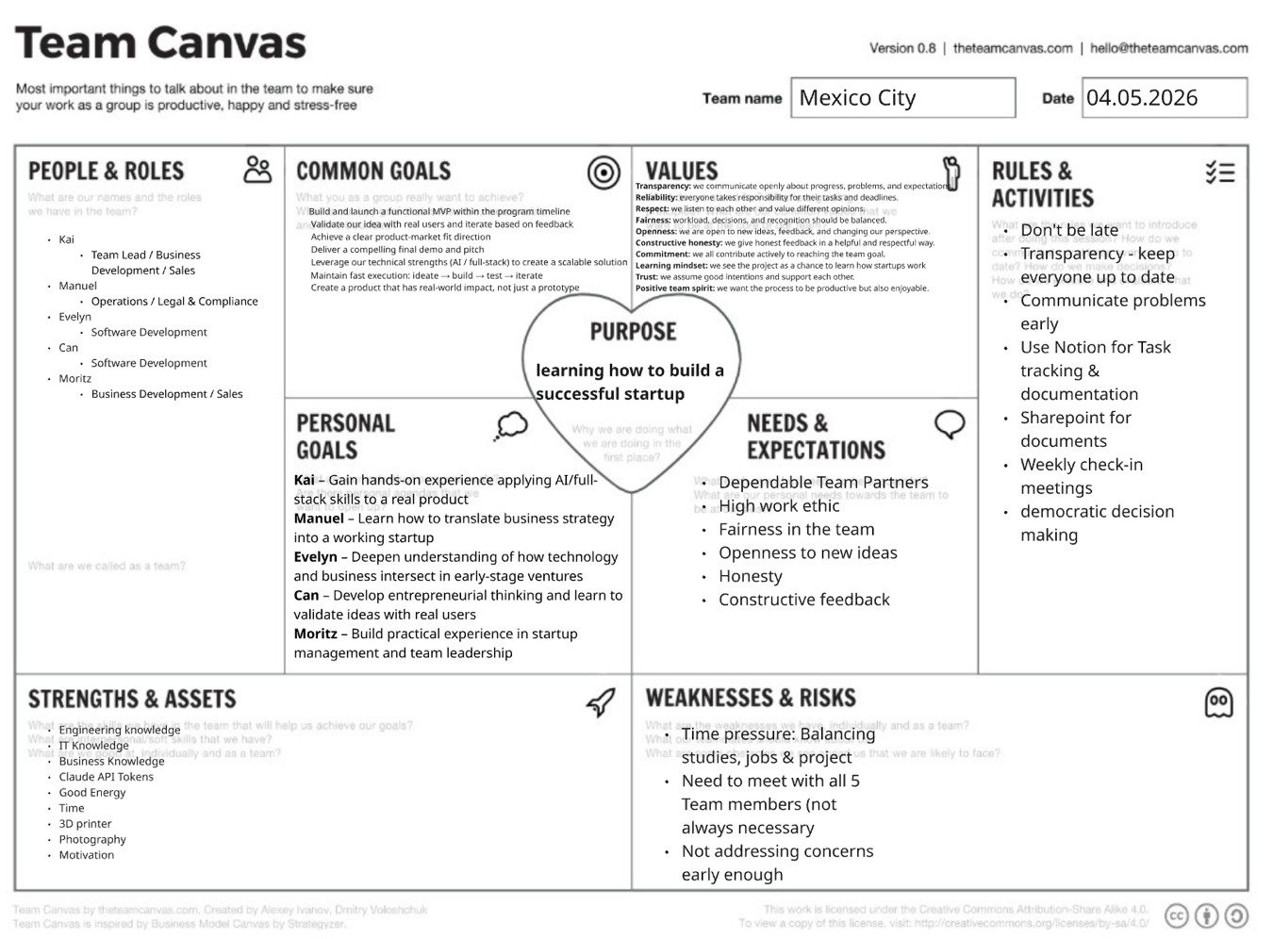

Opportunity Space (2–3 sentences):
The German property management industry is highly fragmented, with over 28,000 Hausverwaltungen / Property Management Firms managing residential and commercial properties — yet most still rely on legacy software, phone calls, and paper-based workflows. Tenants and landlords increasingly expect digital, transparent communication, fast maintenance resolution, and legally compliant documentation, while property managers are overwhelmed by administrative burden. There is a clear opportunity to build an AI-powered platform that streamlines the entire management lifecycle — from tenant communication and rental contract compliance to maintenance coordination and owner reporting.

TOP 3 Arguments why this opportunity matters:

1. Massive, Underserved Market with Low Digital Penetration Germany's property management sector oversees roughly 10 million rental units through 28,000+ Verwaltungen, yet the vast majority still use outdated tools or manual processes. The rental market is structurally growing due to rising homeownership costs, creating more units under professional management — but the software supporting these managers has not kept pace. This gap represents a large, recurring-revenue opportunity with no dominant AI-native player yet.

2. Regulatory Complexity Is Accelerating Demand German property management is one of the most compliance-heavy industries in Europe — WEG-Reform, DSGVO, Betriebskostenabrechnung, and ever-changing tenancy law create constant risk for managers. Manual compliance tracking is error-prone and costly. An AI co-pilot that proactively flags deadlines, generates legally sound documents, and automates meeting minutes for Eigentümerversammlungen directly reduces liability and saves hours of work per property per month.

3. Tenant Expectations Have Shifted — Renting Is the New Normal With homeownership increasingly unaffordable for younger generations, more Germans are renting long-term than ever before. This growing renter class expects digital-first experiences: instant maintenance requests, transparent communication, and digital rent receipts. Property managers who cannot deliver this risk tenant churn and reputational damage. Valta bridges the expectation gap between what renters demand and what traditional Hausverwaltungen can currently deliver.

